***St. Clair College of Applied Arts & Technology***

MIT642 – Network Design

Accessing MS Software – Student License

Microsoft seems to undergo infrastructure and operational changes daily as they reposition themselves as a global leader in the business of Manage Services, (MSP – Managed Services Provider).

In doing so, they manage (strictly control) the software products that students can access.

Hopefully the instructions provided below will work seamlessly for you.

First thing to do is go to this site.

<https://azureforeducation.microsoft.com/devtools>

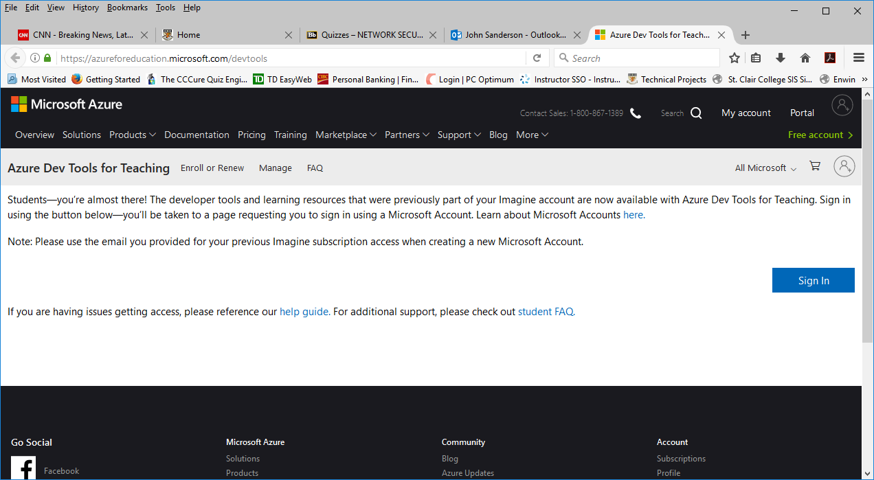

Simply select the Sign In option.

Be aware, your “stclairconnect” e-mail has already been provided to MS Azure. You **will still have to register** to gain access to the authorized software.

When you select “Sign In” you MAY first be presented with the standard “My St. Clair” sign in prompt.

If so, use you existing credentials to authenticate to My St. Clair.

**Do NOT select your name/email if you see the Microsoft “Pick an Account” login prompt**.

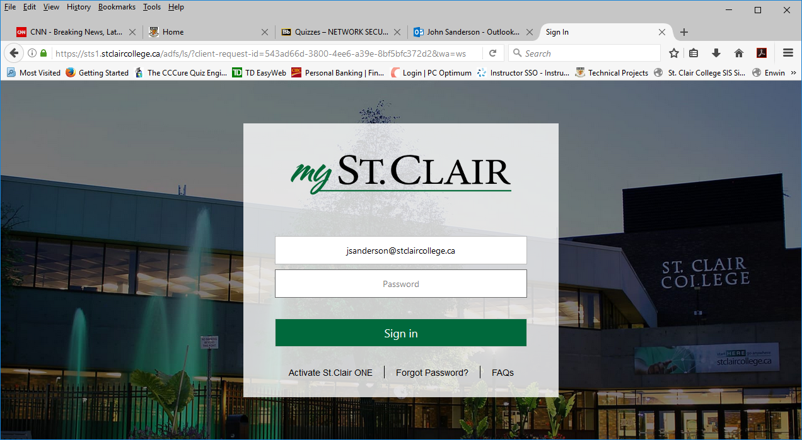 or… 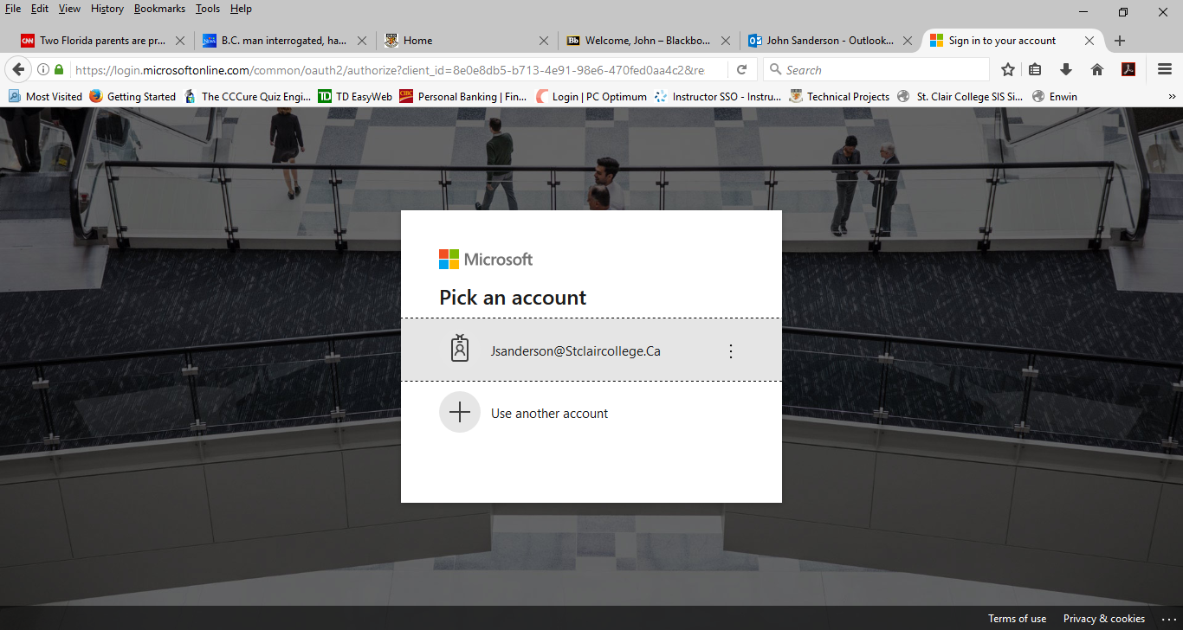

**May** see this first. Log in if you do!

**You MUST select Use another Account!**

(It will be the same college e-mail, but this is all part of the registration process)

If you first get the Microsoft prompt, as shown above (right), you MUST select the “**Use another account**” option!

This will be the start of the Registration process for Azure and their Educational software.

When prompted, enter your **existing StClairConnect** e-mail address, and **use your existing password**. Your new Educational account will now be authenticated through Azure.

Almost there!

You should now see the Azure Portal.

Make sure **All Services** is selected as shown. In the Search Everything field, type, “**Education**”

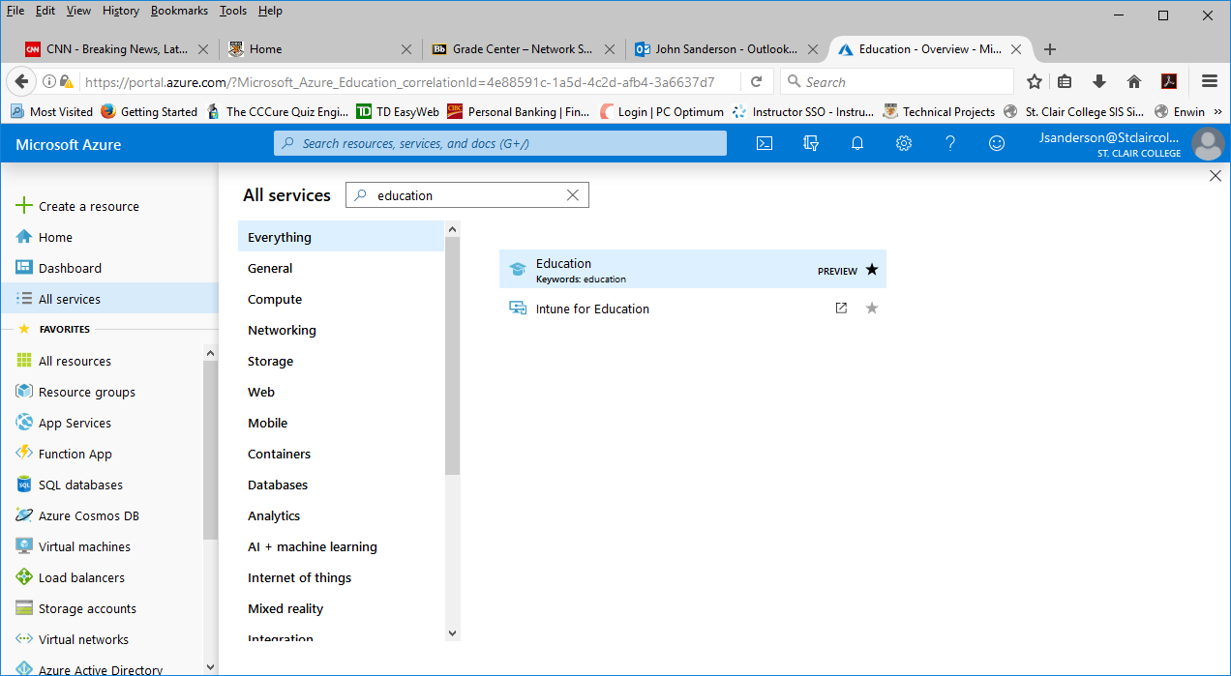

**Then select Education from the contents pane.**

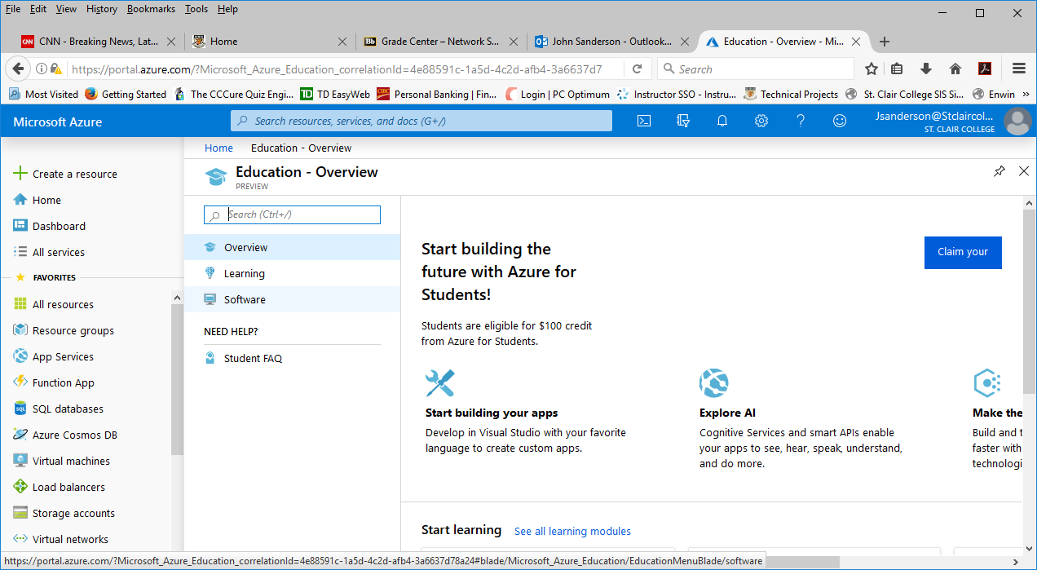

**Now select Software from the central menu options pane.**

Now you will see a list of all the available software you have access to as a St. Clair student. The first VISIO is 2016, the second is 2019. Welcome to try 2019.

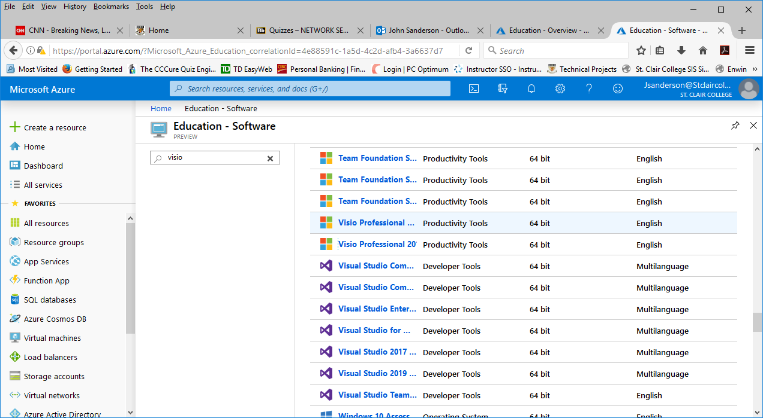

2016

2019

Either one is fine. Remember to use **3 D symbols for your WAN Sample drawings**

Hope that works for you all!

…cheers…